FUNCTIONAL REQUIREMENTS

**Product Name: Open Cart (Frontend)**

1. Functionality

Creating an account

* This Document is intended to be used as an introduction to the OpenCart

Register account Functionality

* Before a customer can continue checking out a product from the shopping cart, the customer needs to select either guest checkout or log into their account. The guest checkout doesn't require log-in details. Returning customers may want to make an account with the store. There are a few ways a customer can make an account

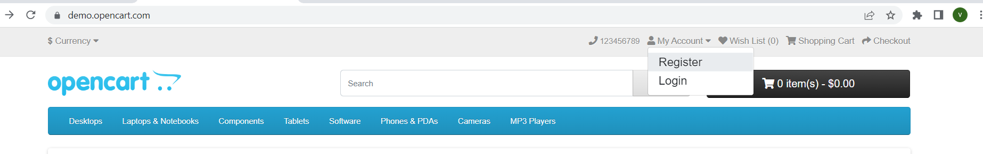

* Clicking "My Account" in the header will show the option for customer to the Login or create account. This page gives the customer an option to log in if they already have an account, or create a new account. In the "New Customer" section the customer can click "Continue" under Register Account to be directed to the "Register an Account" page
* Use Case Diagram

User